Project Design Phase-II

Data Flow Diagram

|  |  |
| --- | --- |
| Date | 17 October 2022 |
| Team ID | PNT2022TMID51106 |
| Project Name | Project – Hazardous Area Monitoring for Industrial Plant powered by IoT. |
| Maximum Marks | 4 Marks |

# Data Flow Diagrams:

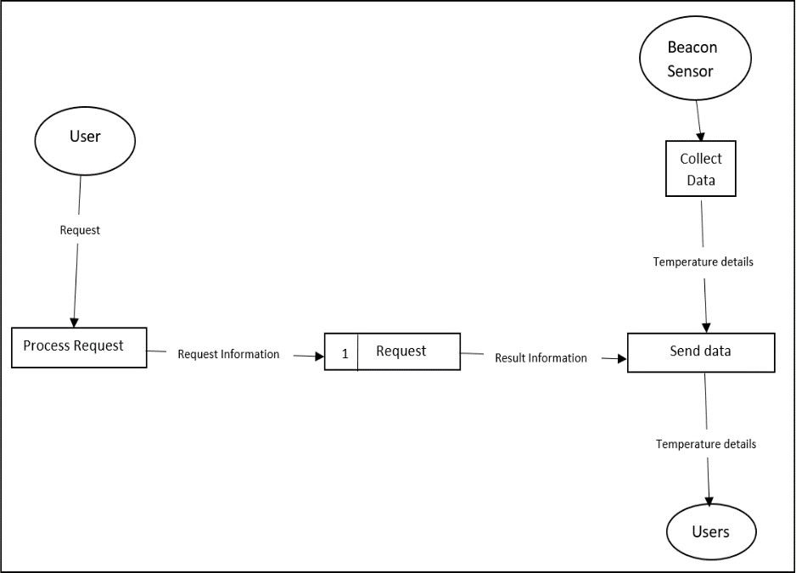

1. The necessary Python code is created to gather temp. information from an IoT device.
2. For data collection, IoT devices are linked to the IBM Watson IoT platform.
3. After the IoT platform is ready, the next stage employs Node-Red services.
4. Cloudant DB is utilised for data archiving and retrieval.
5. Web application and user interface (UI) designs are made using Node-Red services.

6.The user uses a mobile app, web, and smartwatch to get various informations and alerts

DFD Level 0 (Industry Standard)

# User Stories:

|  |  |  |  |  |  |  |
| --- | --- | --- | --- | --- | --- | --- |
| **User Type** | **Functional Requirement (Epic)** | **User Story Number** | **User Story / Task** | **Acceptance criteria** | **Priority** | **Release** |
| Technician | Installation | USN-1 | To guarantee that the entire factory is covered, the technician must install the smart beacons at strategic locations. | Every location in the plant has a beacon. | High | Sprint-1 |
|  | Data Gathering | USN-2 | The beacons use sensors to measure the temperature in their respective areas. | The temperature of areas within the plant is obtained. | High | Sprint-1 |
|  | Data Sync | USN-3 | The administrators dashboard and neighbouring wearable devices receive the data that the beacons relay in real time to the cloud.. | Data is sent to the cloud successfully and synced with other devices. | High | Sprint-1 |
| Worker | Wearable device display | USN-4 | The data transmitted by beacons nearby should be displayed by the wearable device. | On their device, the user can view the local temperature. | High | Sprint-1 |
|  | Wearable device adjustments | USN-5 | The wearable device's size can be changed by the user to fit their needs. | The device can be modified by the user to improve comfort while using it. | Low | Sprint-2 |
|  | Wearable display customization | USN-6 | On the device itself, the user can customise the display to fit their needs. | To make the device's display easier to read, the user can make changes to it. | Medium | Sprint-2 |
|  | SMS Notifications | USN-7 | When the environment they are in reaches unsafe temperatures, the wearable gadget sends a notification to the user's phone via an API. | As soon as the beacons identify a potential threat, they send an SMS to the user to alert them to it. | High | Sprint-1 |
| Administrator | Admin Dashboard | USN-8 | The administrator's dashboard receives the data from the beacons via the cloud. | The plant administrator has access to the data from every beacon. | High | Sprint-1 |
|  | Dashboard Customization | USN-9 | The admin can modify the dashboard to meet their unique needs and goals. | The UI for the administrator's dashboard can be modified. | Medium | Sprint-2 |